Practical activity: Thermal Decomposition of Metal Carbonates
Practical Guide – Simple Oxygen Production

Aim: To compare the thermal stability of various metal carbonates through heating
Notes and guidance
Discuss this practical with your technician colleagues as far in advance as possible so they have time to source equipment and resources.

This practical can be redesigned if there is not enough time for students to test all five metal carbonate samples. For instance, if there are ten groups conducting the experiment, two groups can do each of the five metal carbonates and then the class can compare results at the end.

Metal carbonate compounds are prone to decomposing under high temperatures. This experiment will compare the reactivity of the compounds, test the gas produced (proving it is carbon dioxide) and invite students to consider how the reactivity of the metal in the compound affects the reactivity of the metal carbonate.
Risk Assessment Notes
A risk assessment must be completed for this practical. The risk assessment should be specific to the class involved and written only by the teaching member of staff. For more guidance refer to CLEAPSS. It is good practice for students to wear safety spectacles during all class practicals and demos.

Ensure your class are familiar with basic Bunsen burner safety before carrying out this practical.

Lead carbonate is toxic and dangerous for the environment. Hands must be washed after any possible contact. If you do not trust your class to handle this chemical responsible, leave it out of the practical.

CLEAPSS Hazcards: Limewater (HC018), copper carbonate (HC026), lead carbonate (HC056), sodium and potassium carbonate (HC095A), zinc carbonate (HC108b)
Equipment Per Group | Setup diagram:  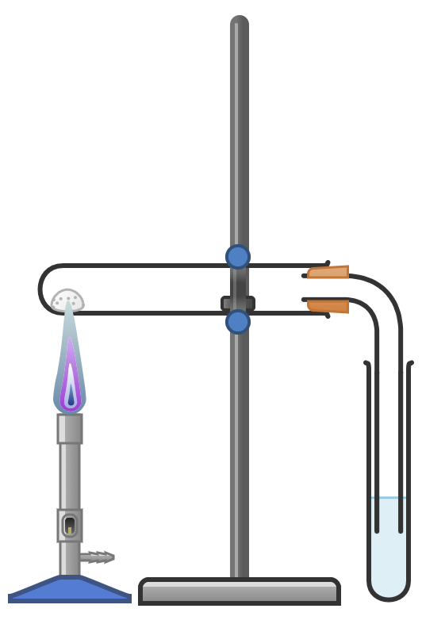
Apparatus:
- Eye protection
- 1x boiling tubes and 1x test tube per carbonate
- Right-angled glass delivery tube
- Spatula
- Retort stand and clamp
- Boiling tube rack
- Bunsen burner
- Heat-proof mat

Chemicals:
- Limewater (calcium hydroxide solution)
- Copper carbonate
- Lead carbonate
- Potassium carbonate
- Sodium carbonate, anhydrous
- Zinc carbonate

(You may wish to provide the boiling tubes pre-filled with the metal carbonates)

Method | Questions To Ask Students During The Practical
- Add one flat spatula measure of the first carbonate to the first boiling tube.  - Add 2 ml of limewater to a test tube and place this in a stable test tube rack.  - Insert the delivery tube/bung and clamp the boiling tube above the Bunsen burner so the delivery tube can be inserted into the limewater, as per the diagram.  - Use the Bunsen burner to heat the metal carbonate at the end of the boiling tube.  - Record on your results table any observations about what has happened to the limewater, the metal carbonate, and how quickly.  - When you stop heating, immediately remove the delivery tube from the limewater to avoid suck-back.  - Repeat the above steps with the other metal carbonates.  - When the experiment has finished, wash your hands thoroughly. | - Why must we take care with lead carbonate and wash our hands after any possible contact? (It is toxic and harmful to the environment.)  - Why do we always light the Bunsen burner on a yellow safety flame? (So it is visible and we are less likely to accidentally burn ourselves on it.)  - Why does opening the hole in the Bunsen burner result in a hotter flame? (More oxygen is allowed in.)  - Why do we not heat the test tube with the safety flame? (The safety flame is less hot than the blue and roaring flames and it also adds a layer of soot to the equipment.)  - Why do we heat the boiling tube at the end? (This is where the metal carbonate is. Also, heating the boiling tube close to the clamp can damage the clamp.)  - What happens to limewater (calcium hydroxide) when carbon dioxide gas is passed through it? (It turns a milky white colour.)  - Why do we remove the delivery tube from the limewater as soon as we finish heating? (If we do not do this, the sudden change in pressure can result in the limewater being violently sucked back into the boiling tube.)  - What did you observe about the sodium and potassium carbonates in this experiment? (They did not decompose)  - What did you observe about the zinc, lead and copper carbonates in this experiment? (These powders changed in appearance and evolved carbon dioxide.)  - How do we explain the change in appearance of these powders? (The metal carbonate decomposed and left a residue of metal oxide in the process.)  - What is the relationship between the reactivity of the metal and the ease with which it decomposes when exposed to heating? (The more reactive metal carbonates are less prone to thermal decomposition.)
Results Table
Carbonate | Initial Colour | Colour After Heating | Gas Evolved | Ease of Decomposition
Potassium carbonate
Sodium carbonate
Zinc carbonate
Lead carbonate
Copper carbonate

Expected Results
Carbonate | Initial Colour | Colour After Heating | Gas Evolved | Ease of Decomposition
Potassium carbonate | White | White | None | Very difficult
Sodium carbonate | White | White | None | Very difficult
Zinc carbonate | White | Yellow when hot, white after cooling | Carbon Dioxide | Relatively easy
Lead carbonate | White | Yellow | Carbon Dioxide | Relatively easy
Copper carbonate | Green | Black | Carbon Dioxide | Very easy

Clearing up
It is important that equipment is returned to the prep room in good order. If safe to do so, rinse used equipment and put it in the used equipment tray. If the trays arrived on a trolley, students must return all trays and equipment to that trolley. Anything dirty needs to be placed into a separate container for washing up. Never put dirty equipment back into a tray with clean equipment.

Consult CLEAPSS Hazcards for waste disposal guidance. Due to the toxic nature of lead carbonate – as well as the fact the equipment will be hot after heating – it may be best to leave the equipment as it is at the end of the lesson. Discuss this with your technician colleagues in advance.

Technician Notes
Discuss this practical with the class teacher ahead of time. Ensure they have considered the risks of this practical and are confident with the techniques used. If necessary, provide them with the CLEAPSS hazcards (identified in the risk section section above) so they are comfortable with the chemicals to be used and how to use and dispose of them safely.

Provide handsoap and paper towels for handwashing if using lead carbonate.

Ensure the chemicals you provide are free from contamination and the equipment is as clean as possible.

